Narra Gopi chand
Registration no: 192371093
C PROGRAM – VOWELS AND CONSONANTS

Program Code
#include <stdio.h>
int main()
{
char ch;
printf("Enter a character: ");
scanf("%c", &ch);
if (ch == 'a' || ch == 'e' || ch == 'i' || ch == 'o' || ch == 'u' ||
ch == 'A' || ch == 'E' || ch == 'I' || ch == 'O' || ch == 'U')
printf("%c is a Vowel", ch);
else
printf("%c is a Consonant", ch);
return 0;
}

Output Screenshot
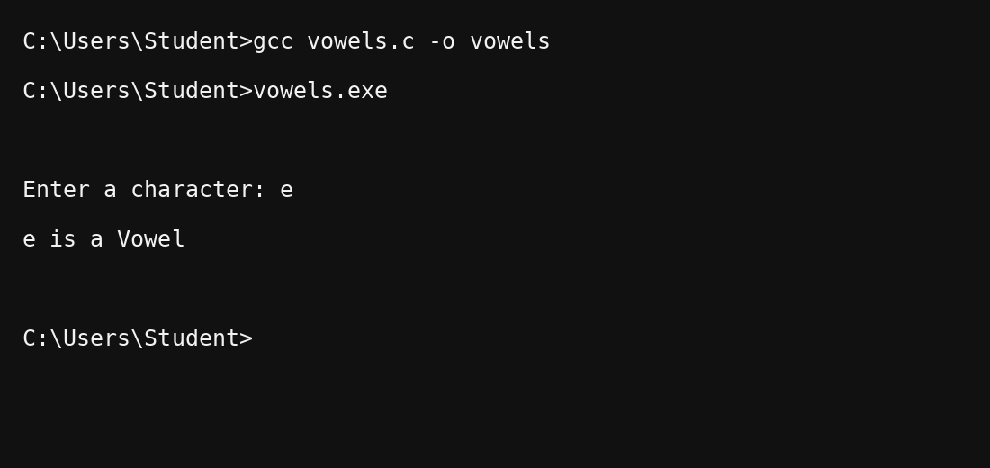
Result: The given character was successfully identified as a vowel or consonant.

